EXPERIMENT 1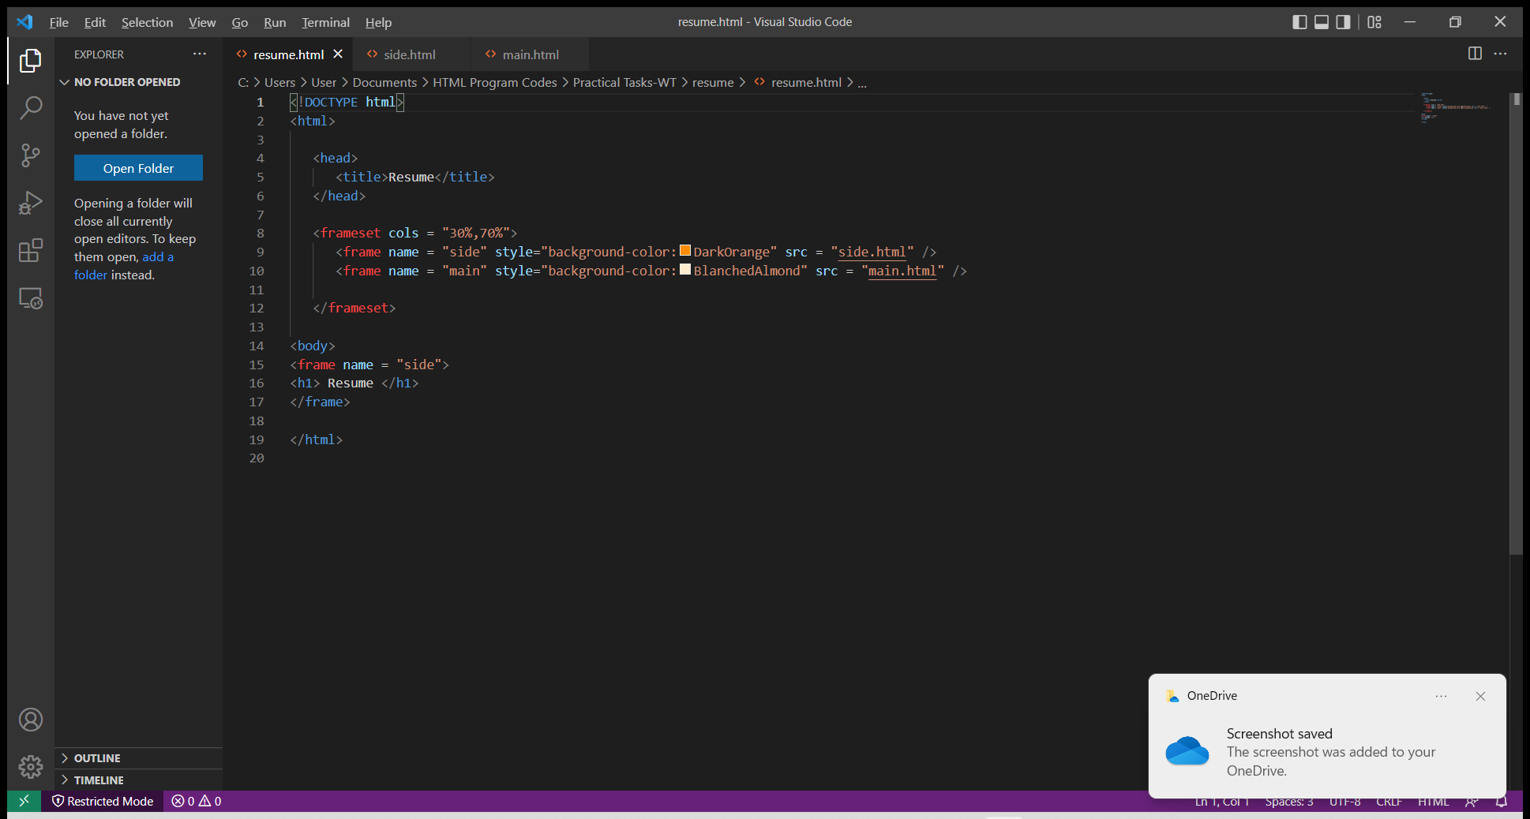

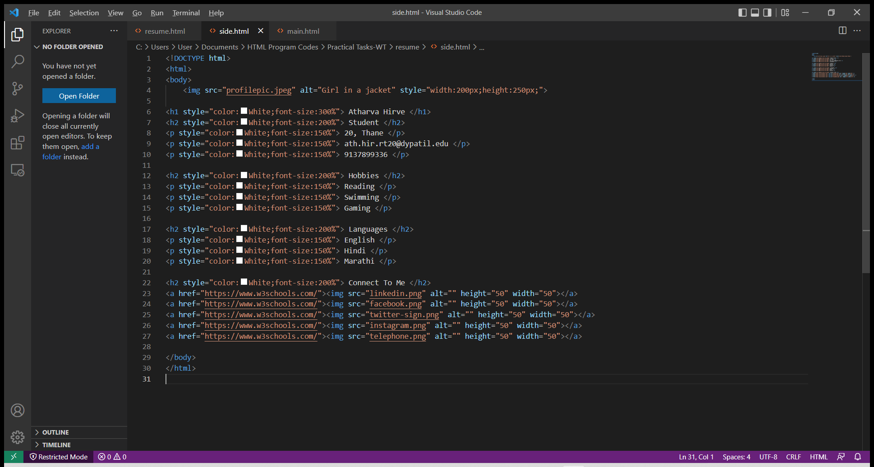

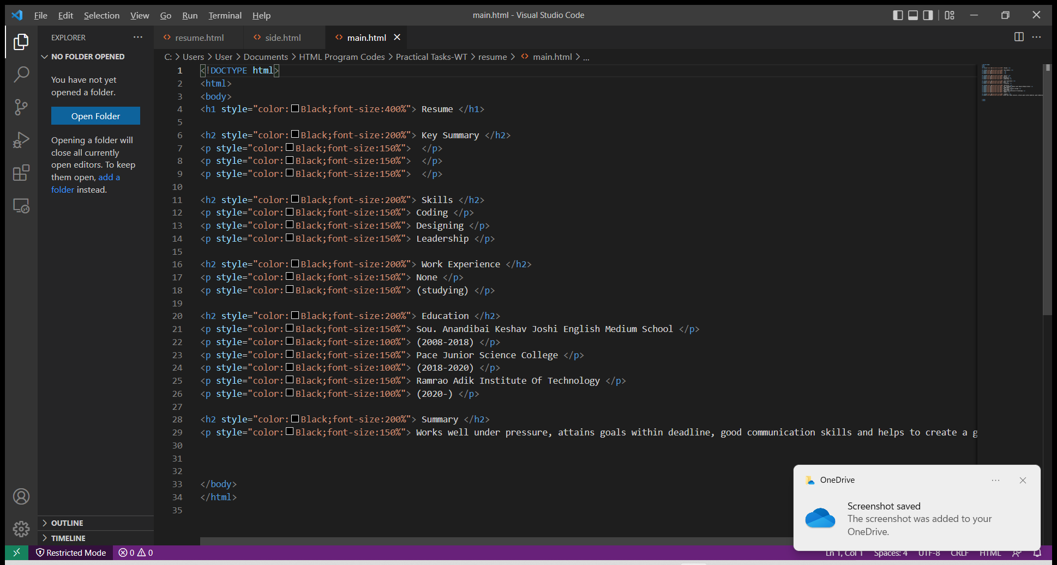

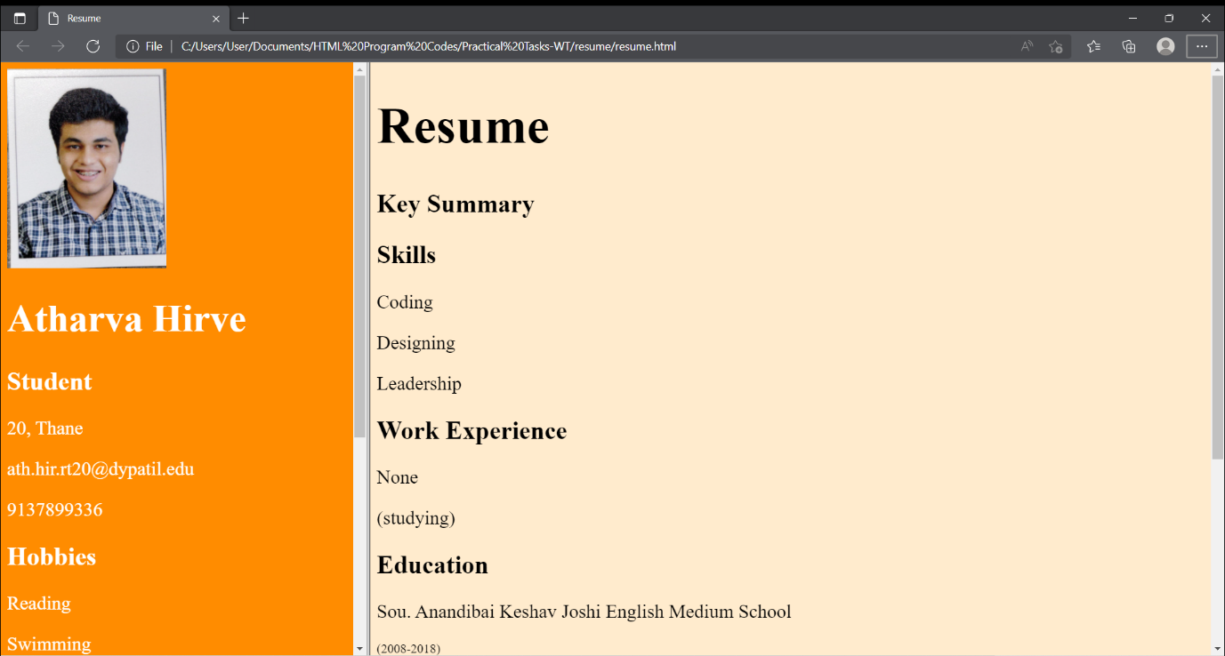

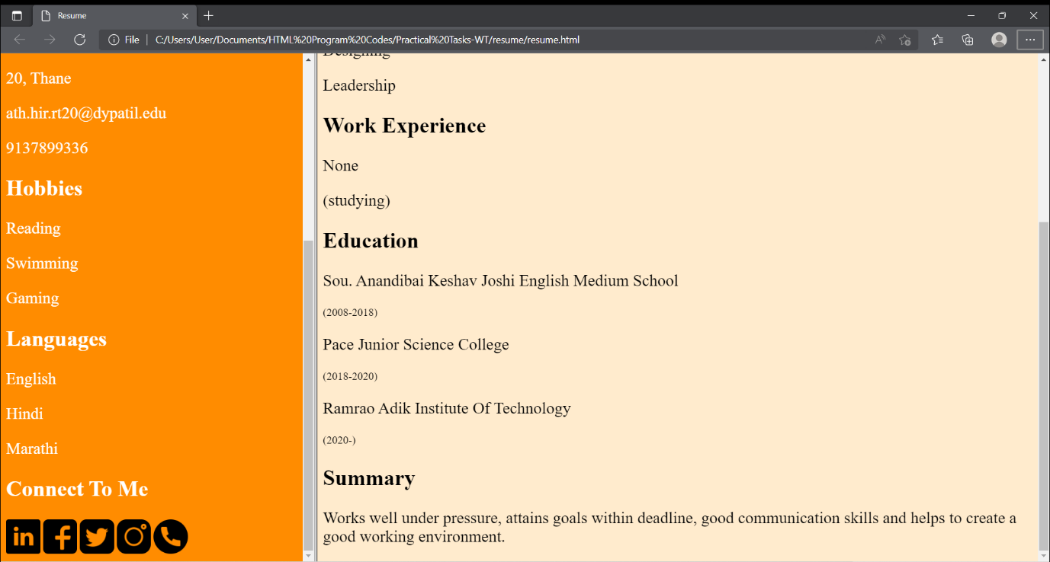

EXPERIMENT 2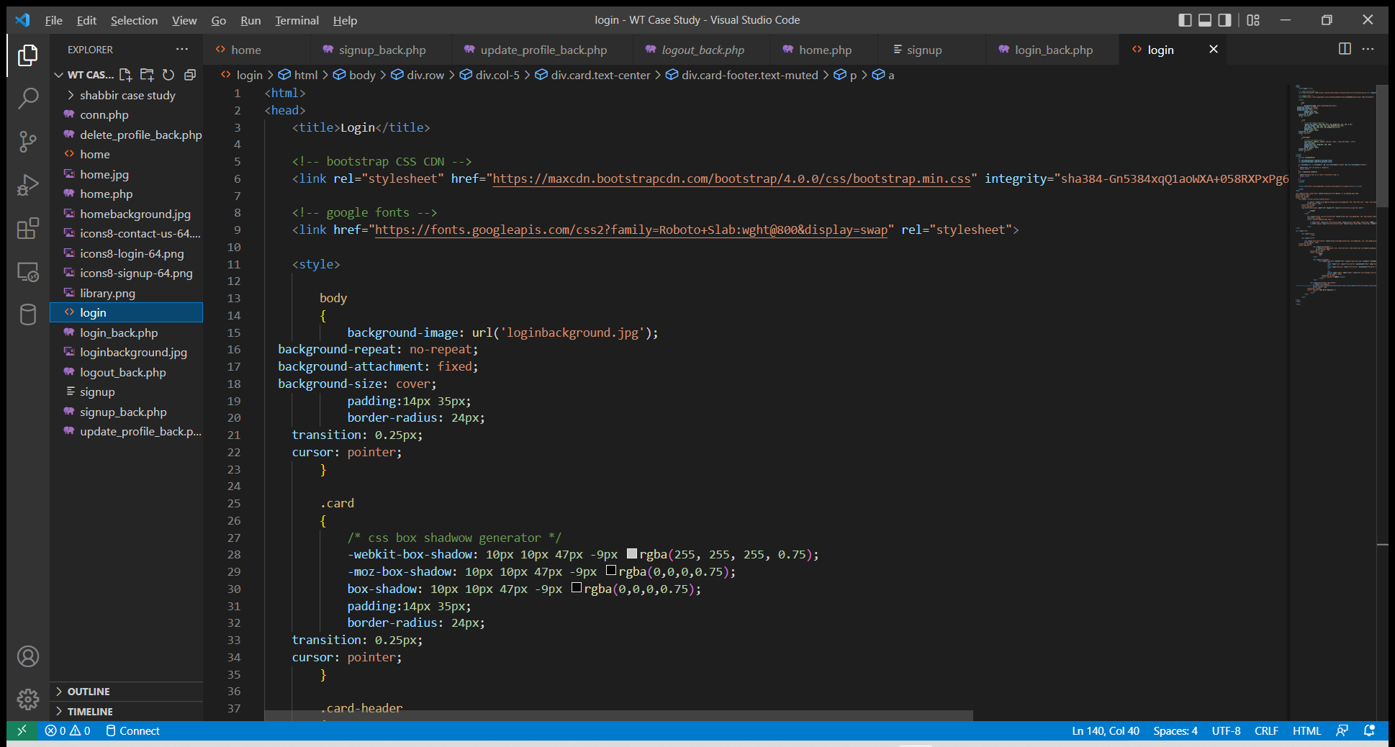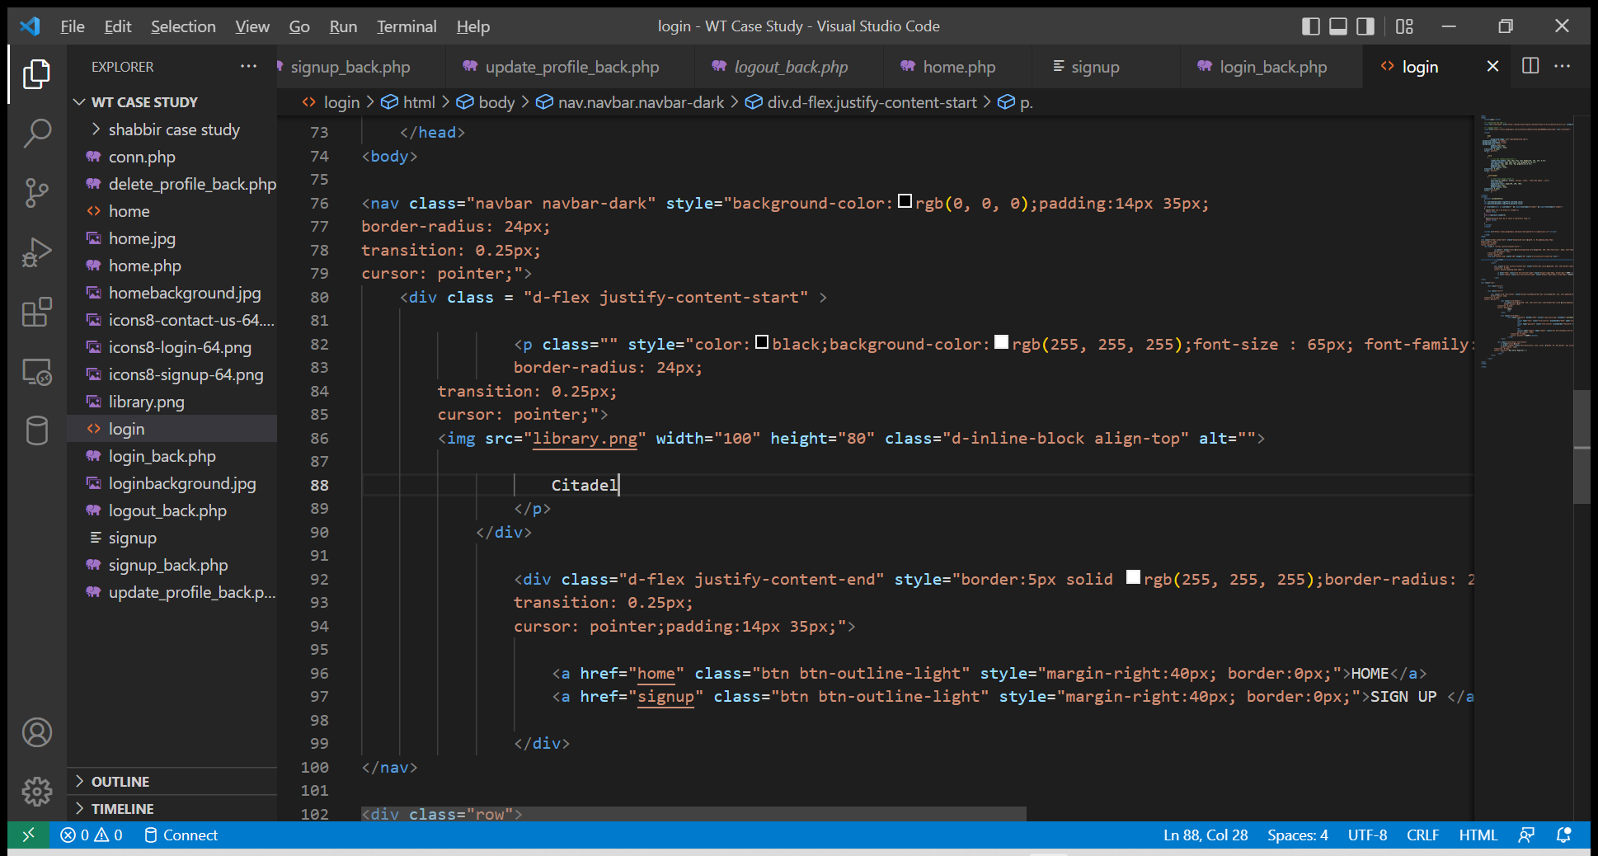

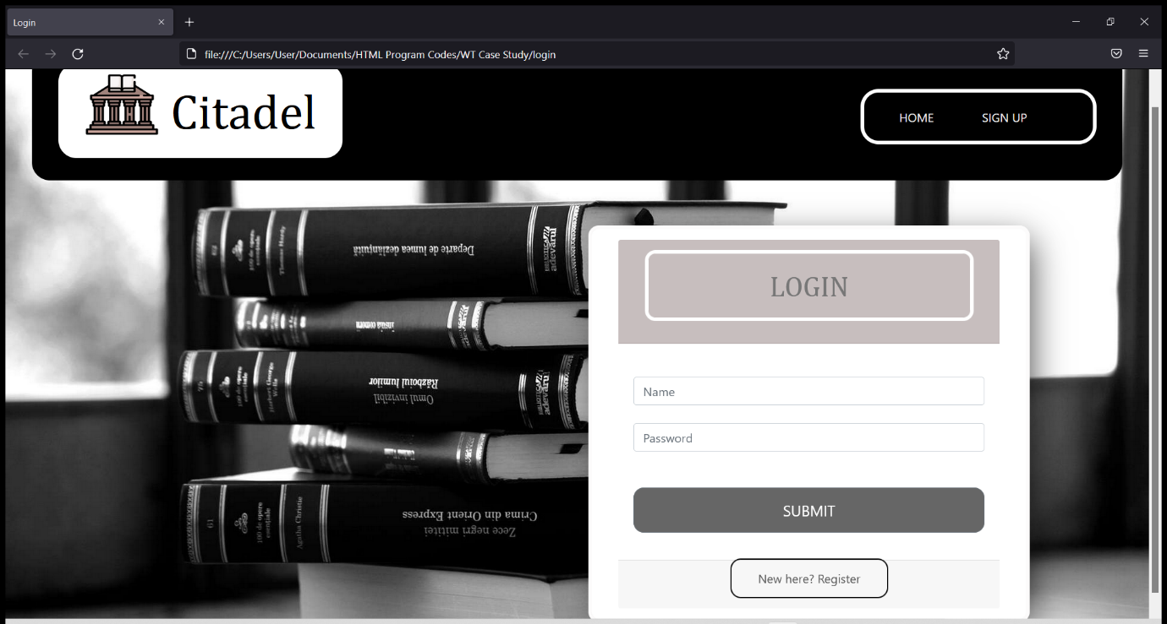

EXPERIMENT 4

**Code:**

<!doctype html>

<html>

<head>

<link rel="stylesheet" href="//code.jquery.com/ui/1.11.2/themes/smoothness/jquery-ui.css">

<script src="//code.jquery.com/jquery-1.10.2.js"></script>

<script src="//code.jquery.com/ui/1.11.2/jquery-ui.js"></script>

<script>

$(document).ready(function() {

$( "#runani" ).click(function() {

$( "#jQuery_accordion" ).animate({

width: "300px",

height: "300px"

}, {

duration: 3000,

specialEasing: {

width: "easeInCubic",

height: "linear",

},

complete: function() {

alert( "Animation complete!" );

}

});

});

});

$(function() {

$( "#jQuery_accordion" ).accordion({

collapsible: true

});

});

</script>

<style>

.ui-accordion .ui-accordion-header {

display: block;

cursor: pointer;

position: relative;

margin: 2px 0 0 0;

padding: .5em .5em .5em .7em;

min-height: 0; /* support: IE7 */

font-size: 100%;

border:1px solid #FDF8E4;

background:#846733;

color:#fff;

}

button{

margin: 50px;

}

</style>

</head>

<body>

<div id="jQuery_accordion">

<h3>Animation example</h3>

<p>

An animation example with jQuery UI widget

</p>

<h3>Content Panel 2</h3>

<p>

jQuery animation 2

<img src="jquery.jpg" />

</p>

<h3>Content Panel 3</h3>

<div>

<p>

jQuery animation 3

</p>

</div>

</div>

<button id="runani">Start animation</button>

</body>

</html>

**Output:**





EXPERIMENT 5

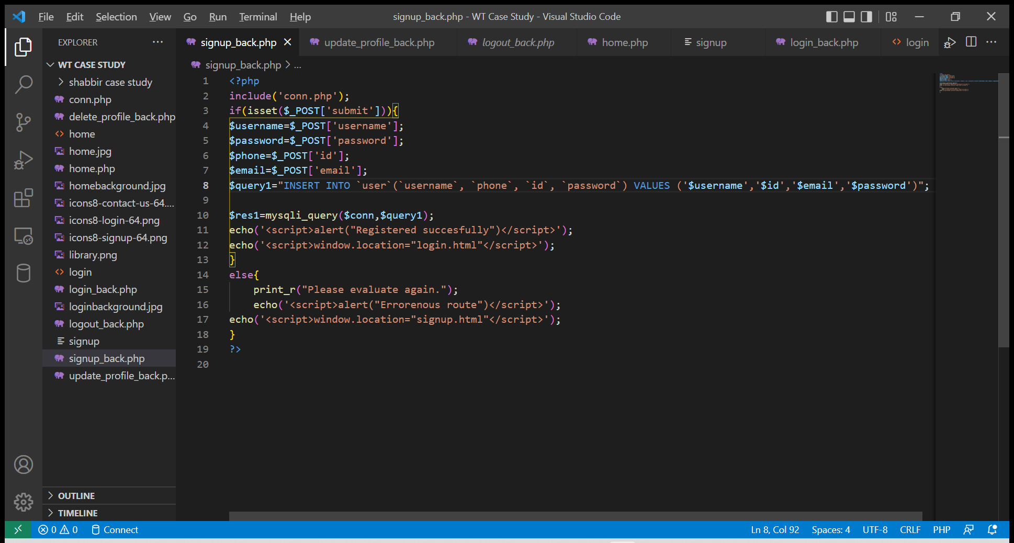

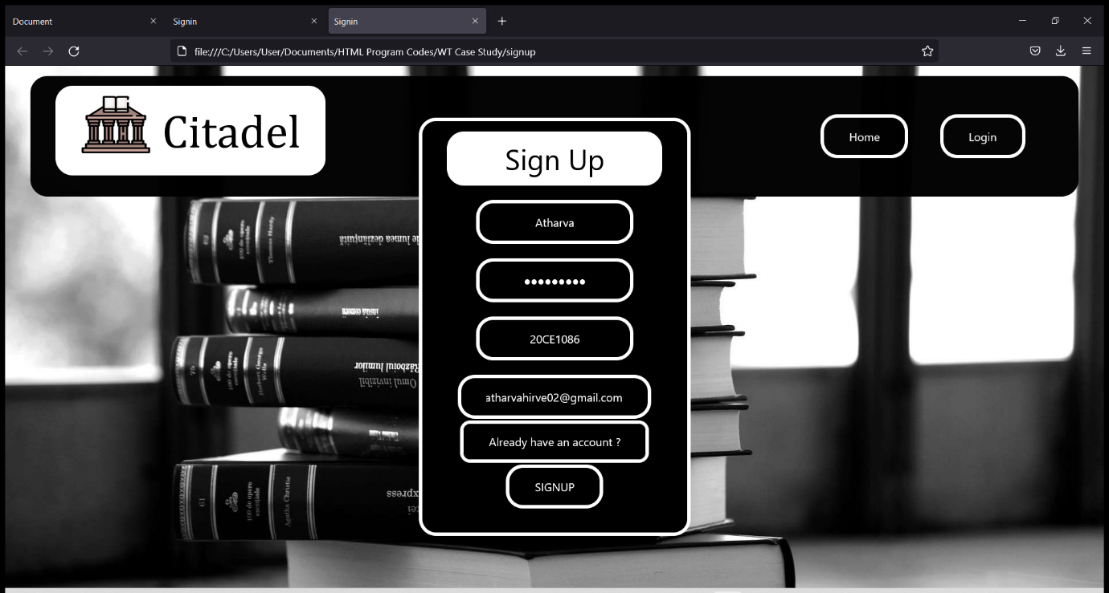

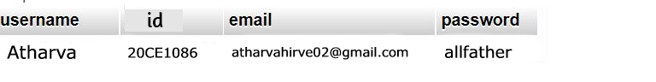

EXPERIMENT 6

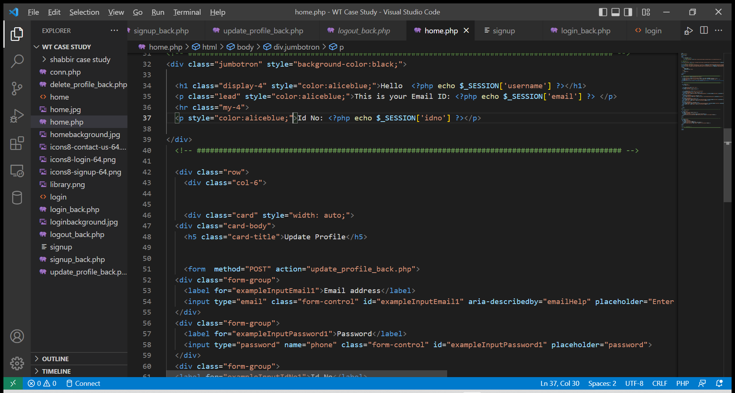

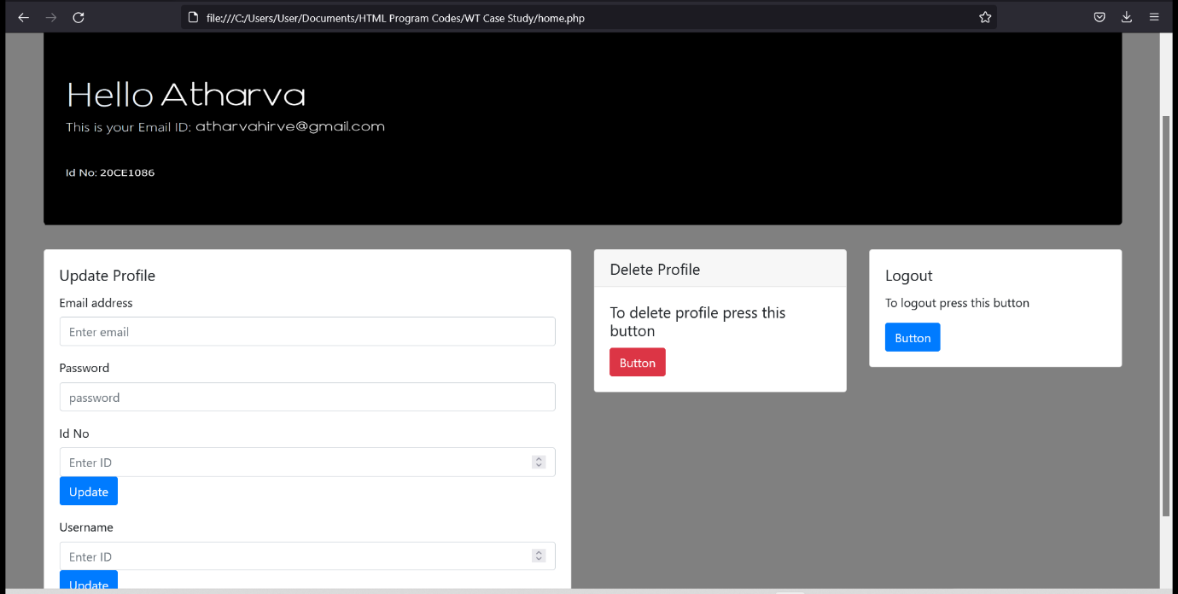

EXPERIMENT 7

XML:

<?xml version="1.0" encoding="UTF-8"?>  
<railway_menu>  
  
<train>  
<name>Thane-CSMT</name>  
<number>96625</number>  
<platform>Platform 1 </platform>  
<time>09:10 A.M.</time>  
</train>  
  
<train>  
<name> Thane-Nerul</name>  
<number>95545</number>  
<platform>Platform 2 </platform>  
<time>09:20 A.M.</time>  
</train>  
  
<train>  
<name> Thane-Vashi</name>  
<number>92645</number>  
<platform>Platform 3 </platform>  
<time>09:05 A.M.</time>  
</train>  
  
<train>  
<name> Thane-Kalyan</name>  
<number>$4.50</number>  
<platform> </platform>  
<time>Cancelled.</time>  
</train>  
  
<train>  
<name> Thane-Pune</name>  
<number>91240</number>  
<platform>Platform 5 </platform>

<time>09:00 A.M.</time>

</train>  
  
</railway_menu>

XLST:

<?xml version="1.0" encoding="UTF-8"?>  
<html xsl:version="1.0" xmlns:xsl="http://www.w3.org/1999/XSL/Transform">  
<body style="font-family:Arial;font-size:12pt;background-color:#EEEEEE">  
<xsl:for-each select="railway_menu/train">  
  <div style="background-color:darkblue;color:black;padding:4px">  
    <span style="font-weight:bold"><xsl:value-of select="name"/> - </span>  
    <xsl:value-of select="number"/>  
    </div>  
  <div style="margin-left:20px;margin-bottom:1em;font-size:10pt">  
    <p>  
    <xsl:value-of select="platform"/>  
    <span style="font-style:italic"> (<xsl:value-of select="time"/> time per serving)</span>  
    </p>  
  </div>  
</xsl:for-each>  
</body>  
</html>

Output:

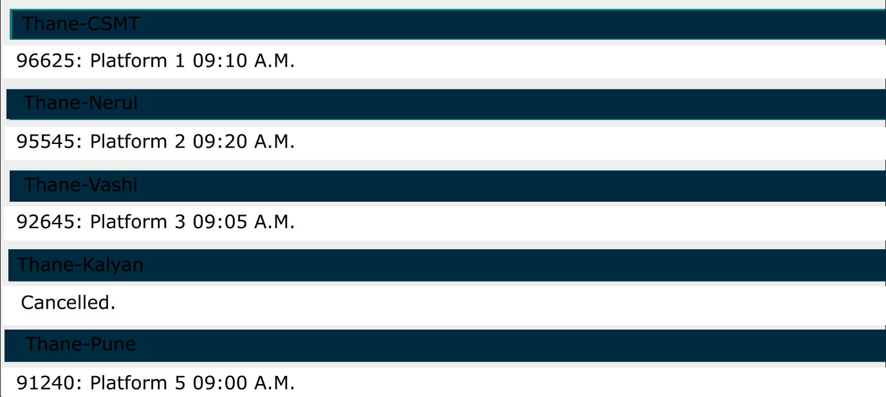

EXPERIMENT 3

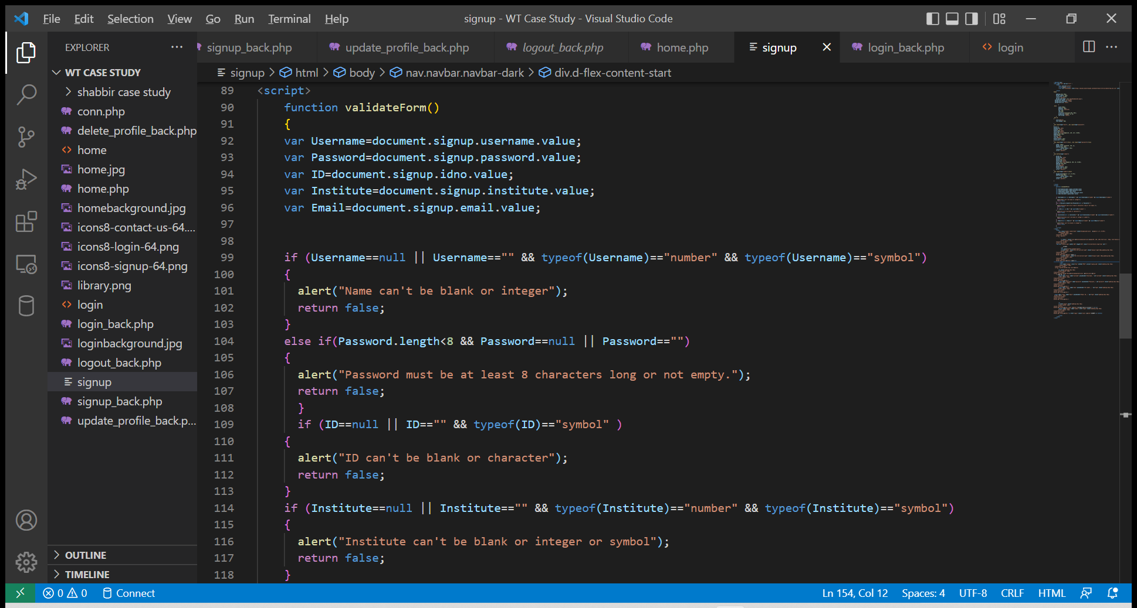

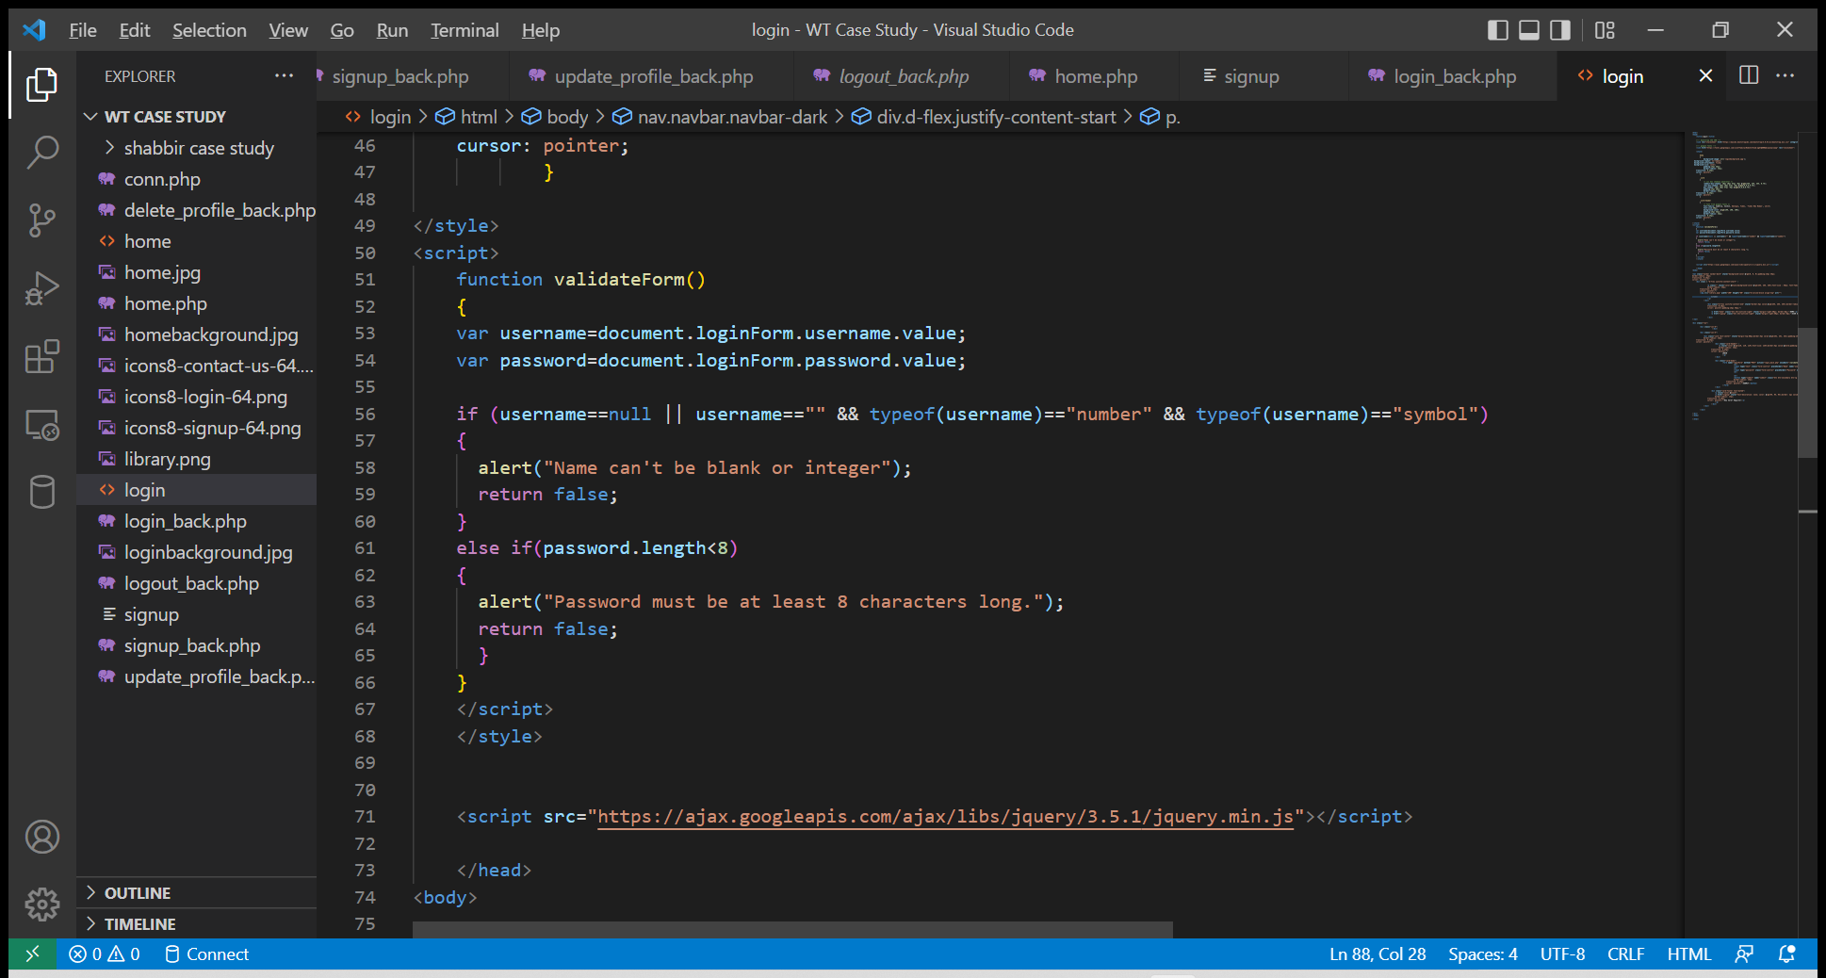

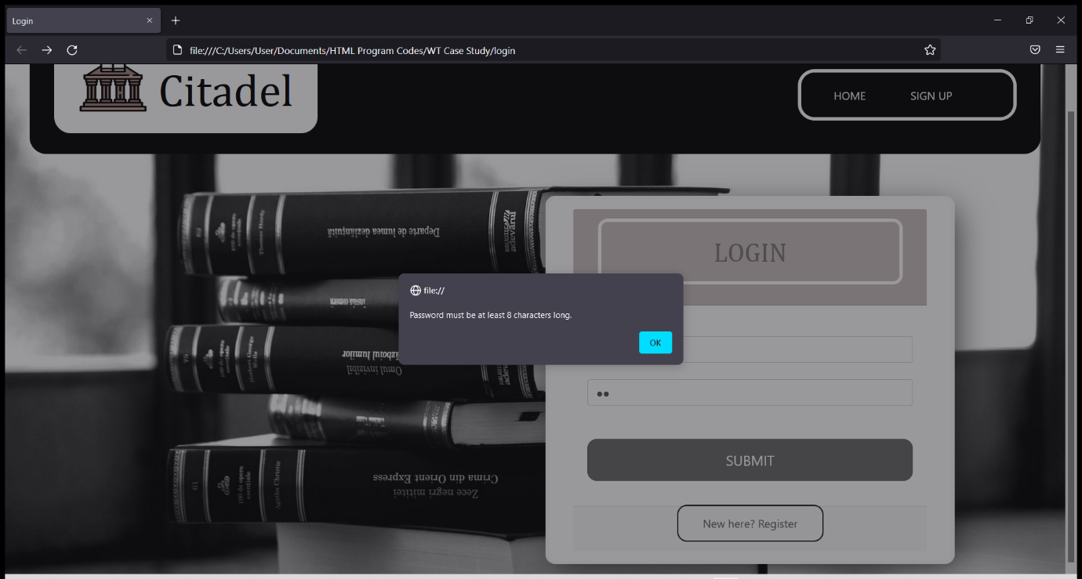

EXPERIMENT 8

**Code:**

<?xml version="1.0" encoding="utf-8"?>

<androidx.constraintlayout.widget.ConstraintLayout xmlns:android="http://schemas.android.com/apk/res/android"

xmlns:app="http://schemas.android.com/apk/res-auto"

xmlns:tools="http://schemas.android.com/tools"

android:layout_width="match_parent"

android:layout_height="match_parent"

android:background="@drawable/bb"

tools:context=".LoginActivity">

<TextView

android:id="@+id/logo"

android:layout_width="wrap_content"

android:layout_height="wrap_content"

android:text="Login"

android:textColor="@color/colorWhite"

android:textSize="36sp"

android:textStyle="bold"

app:layout_constraintBottom_toBottomOf="parent"

app:layout_constraintEnd_toEndOf="parent"

app:layout_constraintStart_toStartOf="parent"

app:layout_constraintTop_toTopOf="parent"

app:layout_constraintVertical_bias="0.13" />

<EditText

android:id="@+id/inputPassword"

android:layout_width="0dp"

android:layout_height="wrap_content"

android:layout_marginTop="16dp"

android:background="@drawable/input_bg"

android:drawableLeft="@drawable/ic_person"

android:drawablePadding="10dp"

android:ems="10"

android:hint="Username"

android:inputType="textPersonName"

android:paddingLeft="20dp"

android:paddingTop="10dp"

android:paddingRight="10dp"

android:paddingBottom="10dp"

android:textColor="@color/colorWhite"

android:textColorHint="@color/colorWhite"

app:layout_constraintEnd_toEndOf="@+id/inputEmail"

app:layout_constraintHorizontal_bias="1.0"

app:layout_constraintStart_toStartOf="@+id/inputEmail"

app:layout_constraintTop_toBottomOf="@+id/inputEmail" />

<EditText

android:id="@+id/inputEmail"

android:layout_width="0dp"

android:layout_height="wrap_content"

android:layout_marginStart="32dp"

android:layout_marginTop="64dp"

android:layout_marginEnd="32dp"

android:background="@drawable/input_bg"

android:drawableLeft="@drawable/ic_email"

android:drawablePadding="10dp"

android:ems="10"

android:hint="Email"

android:inputType="textPersonName"

android:paddingLeft="20dp"

android:paddingTop="10dp"

android:paddingRight="10dp"

android:paddingBottom="10dp"

android:textColor="@color/colorWhite"

android:textColorHint="@color/colorWhite"

app:layout_constraintEnd_toEndOf="parent"

app:layout_constraintHorizontal_bias="0.0"

app:layout_constraintStart_toStartOf="parent"

app:layout_constraintTop_toBottomOf="@+id/logo" />

<TextView

android:id="@+id/forgotPassword"

android:layout_width="wrap_content"

android:layout_height="wrap_content"

android:layout_marginTop="16dp"

android:text="Forgot Password?"

android:textColor="@color/colorWhite"

android:textSize="18sp"

android:textStyle="bold"

app:layout_constraintEnd_toEndOf="@+id/inputPassword"

app:layout_constraintTop_toBottomOf="@+id/inputPassword" />

<Button

android:id="@+id/btnlogin"

android:layout_width="0dp"

android:layout_height="wrap_content"

android:layout_marginTo="24dp"

android:background="@drawable/btn_bg"

android:text="Login"

app:layout_constraintEnd_toEndOf="@+id/inputPassword"

app:layout_constraintStart_toStartOf="@+id/inputPassword"

app:layout_constraintTop_toBottomOf="@+id/forgotPassword" />

<LinearLayout

android:id="@+id/linearLayout"

android:layout_width="0dp"

android:layout_height="wrap_content"

android:layout_marginTop="16dp"

android:gravity="center"

android:orientation="horizontal"

android:textAlignment="center"

app:layout_constraintEnd_toEndOf="@+id/btnlogin"

app:layout_constraintHorizontal_bias="0.0"

app:layout_constraintStart_toStartOf="@+id/btnlogin"

app:layout_constraintTop_toBottomOf="@+id/btnlogin">

<TextView

android:layout_width="wrap_content"

android:layout_height="wrap_content"

android:text="Dont have an Account?"

android:textColor="@color/colorWhite" />

<TextView

android:id="@+id/textViewSignUp"

android:layout_width="wrap_content"

android:layout_height="wrap_content"

android:text="SignUp"

android:textColor="@color/colorRed" />

</LinearLayout>

<Button

android:id="@+id/btnGoogle"

android:layout_width="0dp"

android:layout_height="wrap_content"

android:layout_marginStart="32dp

android:background="@drawable/btn_bg"

android:drawableLeft="@drawable/ic_google"

android:paddingLeft="20dp"

android:text="Google"

</androidx.constraintlayout.widget.ConstraintLayout>

**Output:**

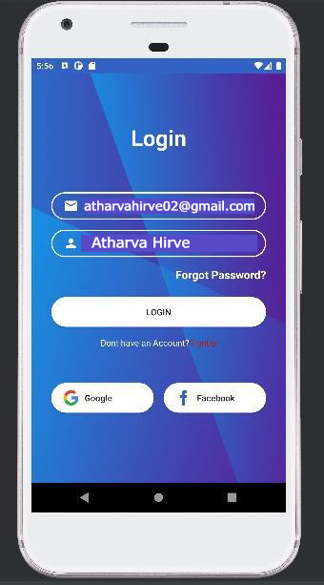

EXPERIMENT 9

**Code:**

<?xml version="1.0" encoding="utf-8"?>

<LinearLayout xmlns:android="http://schemas.android.com/apk/res/android"

xmlns:app="http://schemas.android.com/apk/res-auto"

xmlns:tools="http://schemas.android.com/tools"

android:layout_width="match_parent"

android:layout_height="match_parent"

android:orientation="vertical"

android:background="@color/equl_text_color"

tools:context=".MainActivity">

<LinearLayout

android:layout_width="match_parent"

android:layout_height="wrap_content"

android:background="#8742f5"

android:orientation="vertical">

<EditText

android:id="@+id/input_box"

android:layout_width="match_parent"

android:layout_height="130dp"

android:paddingTop="50dp"

android:gravity="right"

android:textColor="@color/equl_text_color"

android:inputType="none"

android:textSize="40sp"

android:background="#8742f5"

android:ems="10"/>

<TextView

android:id="@+id/result_box"

android:layout_width="match_parent"

android:layout_height="80dp"

android:background="#8742f5"

android:textColor="@color/equl_text_color"

android:gravity="right"

android:textSize="20dp" />

</LinearLayout>

<LinearLayout

android:layout_width="wrap_content"

android:layout_height="wrap_content"

android:layout_gravity="right"

android:layout_margin="5dp"

android:orientation="horizontal">

<ImageButton

android:id="@+id/butdelet"

android:layout_width="wrap_content"

android:layout_height="wrap_content"

android:background="@drawable/ic_backspace_button"

app:srcCompat="@drawable/ic_backspace_button" />

</LinearLayout>

<LinearLayout

android:layout_width="match_parent"

android:layout_height="match_parent"

android:orientation="vertical">

<LinearLayout

android:layout_width="match_parent"

android:layout_height="wrap_content"

android:layout_weight="1"

android:background="@color/equl_text_color"

android:orientation="horizontal">

<Button

android:id="@+id/but7"

android:layout_width="match_parent"

android:layout_height="match_parent"

android:layout_weight="1"

android:layout_marginLeft="10dp"

android:layout_marginRight="10dp"

android:layout_marginTop="10dp"

android:layout_marginBottom="10dp"

android:background="@drawable/number_button"

android:text="7"

android:onClick="onClickNumber"

android:textSize="24sp"/>

<Button

android:id="@+id/but8"

android:layout_width="match_parent"

android:layout_height="match_parent"

android:layout_weight="1"

android:layout_marginLeft="10dp"

android:layout_marginRight="10dp"

android:layout_marginTop="10dp"

android:layout_marginBottom="10dp"

android:background="@drawable/number_button"

android:text="8"

android:onClick="onClickNumber"

android:textSize="24sp"/>

<Button

android:id="@+id/but9"

android:layout_width="match_parent"

android:layout_height="match_parent"

android:layout_weight="1"

android:layout_marginLeft="10dp"

android:layout_marginRight="10dp"

android:layout_marginTop="10dp"

android:layout_marginBottom="10dp"

android:background="@drawable/number_button"

android:text="9"

android:onClick="onClickNumber"

android:textSize="24sp"/>

<Button

android:id="@+id/butadd"

android:layout_width="match_parent"

android:layout_height="match_parent"

android:layout_weight="1"

android:layout_marginTop="10dp"

android:layout_marginLeft="10dp"

android:layout_marginRight="10dp"

android:layout_marginBottom="10dp"

android:background="@drawable/operation_button"

android:onClick="onClickOperator"

android:text="+"

android:textColor="@color/equl_text_color"

android:textSize="24sp" />

</LinearLayout>

<LinearLayout

android:layout_width="match_parent"

android:layout_height="wrap_content"

android:layout_weight="1"

android:onClick="onClickNumber"

android:background="@color/equl_text_color"

android:orientation="horizontal">

<Button

android:id="@+id/but4"

android:layout_width="match_parent"

android:layout_height="match_parent"

android:layout_weight="1"

android:layout_marginLeft="10dp"

android:layout_marginRight="10dp"

android:layout_marginTop="10dp"

android:layout_marginBottom="10dp"

android:background="@drawable/number_button"

android:text="4"

android:onClick="onClickNumber"

android:textSize="24sp"/>

<Button

android:id="@+id/but5"

android:layout_width="match_parent"

android:layout_height="match_parent"

android:layout_weight="1"

android:layout_marginLeft="10dp"

android:layout_marginRight="10dp"

android:layout_marginTop="10dp"

android:layout_marginBottom="10dp"

android:background="@drawable/number_button"

android:text="5"

android:onClick="onClickNumber"

android:textSize="24sp"/>

<Button

android:id="@+id/butmin"

android:layout_width="match_parent"

android:layout_height="match_parent"

</LinearLayout>

</LinearLayout>

</LinearLayout>

**Output:**

